# Introduction

This project mainly focuses on creating a Sydney tourism advisory website for the consumer based on web application development. Users can register as members of this website to obtain information on various tourist sites in Sydney and plan their own trips. We will provide information including local attractions, transportation, restaurants, weather, etc., in Sydney and offer budgeting assistance and checklist consultation.

# Background

During the COVID-19 pandemic, international, regional, and local travel restrictions immediately impacted our economies, including the tourism systems [1]. However, for now, major global economies have legally lifted travel restrictions, paving the way for rapid development in the tourism industry. Taking China as an example, they will stop requiring inbound travellers to go into quarantine starting from Jan. 8, 2023[2]. At the same time, the use of Internet technology in the tourism industry has increasingly become mainstream. In a survey based on hotel guests in Seattle, nearly 80 per cent of the hotel guests used the Internet to search for hotels, whereas less than 5 per cent of the respondents consulted travel agents [3].

In the post-pandemic era, if we can seize the opportunity to create a convenient travel web application, it's foreseeable that this project will have a very promising outlook. Our website will possess basic travel information features, allowing users to search for travel advice and other information through our site. Detailed functionalities will be provided later in this proposal.

Although current travel-related websites on the market have professional data processing teams that offer comprehensive travel consultation support to individual users, we still observe that beyond reviews and user forums, these websites don't offer much in terms of user communication features. Also, these websites seldom inform users about what kind of preparations are needed before travelling, such as budgeting and essential travel items.

To research mainstream travel websites in the market, we utilised Similarweb to gather information. Similarweb is a platform that puts web information all together through data models. According to the platform's travel website usage rankings [4], we can see that the top three are: Booking, TripAdvisor, and Airbnb.

**FIGURE 1. The top 3 travel websites according to Similarweb**

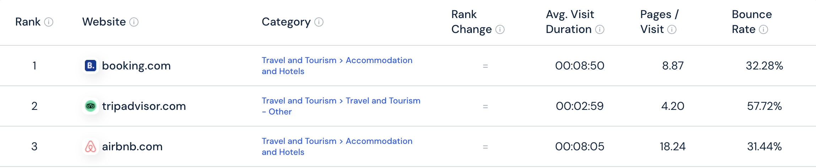

As we can see on those websites, Booking and Airbnb primarily offer booking services for hotels, homestays, and other accommodations. They also provide services for purchasing flight tickets, tourist tickets, etc., based on users' destinations.

**FIGURE 2. Webpage screenshot of Booking, Airbnb and Tripadvisor**

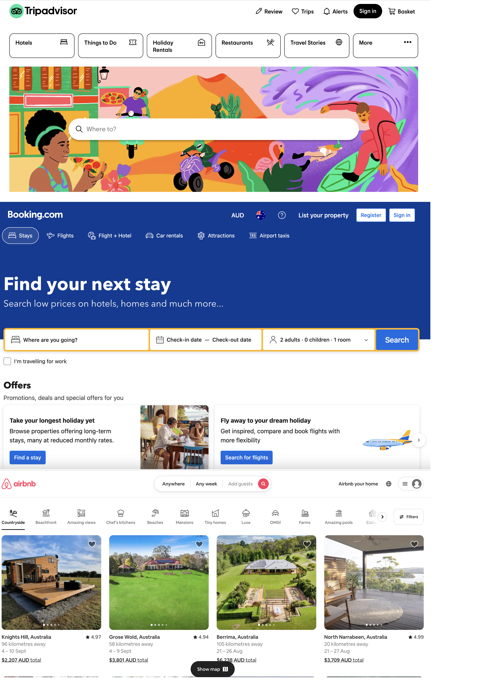

On the other hand, TripAdvisor merges attraction information, offering users travel advice related to their destinations and features a forum for users to review attractions.

Therefore, to enhance user interaction, we will implement a group feature on our website, assisting users in finding fellow travellers heading to the same destination or forming travel teams with their friends. We will provide information to users through these groups.

Moreover, mainstream platforms lack basic guidance for users' pre-trip preparations. To assist users in better planning their trips, we will introduce a budget planner and a checklist feature.

Based on this, our website will differ from mainstream sites. This project will be close to a travel information platform like TripAdvisor but will include practical features that make it different from mainstream platforms.

Lastly, considering our team size and project timeline, this project will only cover Sydney, a popular tourist destination, for tourism information. This way will help us in gathering information and merging data more simply, ensuring a better user experience.

References:  
[1] Gössling, S., Scott, D., & Hall, C. M. (2020). Pandemics, tourism and global change: a rapid assessment of COVID-19. Journal of sustainable tourism, 29(1), 1-20.

1. <https://www.reuters.com/world/china/china-drop-covid-quarantine-rule-inbound-travellers-jan-8-2022-12-26/.>
2. Jordan, E. J., Norman, W. C., & Vogt, C. A. (2013). A cross-cultural comparison of online travel information search behaviors. Tourism Management Perspectives, 6, 15-22.
3. https://www.similarweb.com/top-websites/travel-and-tourism/